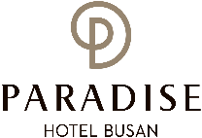
PARADISE HOTEL BUSAN  RESERVATION REQUEST | KMB 2020  (한국미생물∙생명공학회 학술대회)
*Check In Date: 2020. 08. |  | *Check Out Date: 2020. 08. | 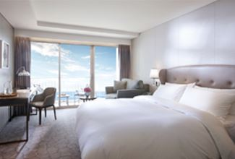  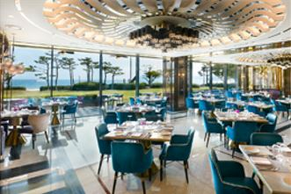  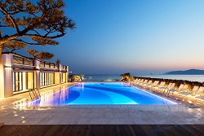
*No. of Persons:
*Name:
*Telephone: |  | *E-mail:
*PAYMENT (FOR GUARANTEE)
Credit Card Type: ☐Etc. ☐Visa ☐Masters ☐Amex(4Digit-number : )
Expiry Date:
Credit Card Number:
Card Holder’s Name:
ROOM TYPE |  | *SPECIAL ROOM RATE | OTHERS RATE
DELUXE CITY VIEW |  | ☐ KRW 217,800 (King)  ☐ KRW 217,800 (Twin) | Breakfast Buffet  KRW 42,000 /Pers.(성인)  KRW 29,000 /Pers.(초등학생)  ☐Extra Bed: KRW72,600/Day
DELUXE OCEAN VIEW |  | ☐ KRW 266,200 (King)
DELUXE OCEAN TERRACE VIEW |  | ☐ KRW 290,400 (King)  ☐ KRW 290,400 (Twin)
* Friday Surcharge : KRW 12,100 (금요일 숙박시 인상요금)
* Saturday Surcharge : KRW 72,600 (금요일 숙박시 인상요금)
* The rates above are non-commissionable, and they are Inclusive of 10% Service Charge and 10% Government Tax.
* The rates above are Not Included breakfast.
* Check-in time is 3p.m. Check out time is 11:30 a.m. (If you pass the check-out time, the following rates will apply)
Until 3pm: 50% of the room rate, After 3pm: 100% of the room rate
* FREE ACCESS : Swimming pool, Fitness center, Play station zone, Kids zone
* 50% Special Discount on admission to Sauna and Outdoor hot spring ‘Cimer’
* CANCELLATION POLICY (Policies: Cancellation or No-Show after the room reservation is being charged as below:
From 7days to 4days prior to Arrival date : 30% of the Room charge/ From 3days to 2days prior to Arrival date : 50% of the Room charge/ From 1days or less prior to Arrival date : no refund)
상기 본인은 상기 예약사항에 대해서 지불을 보증하며 개런티 된 신용카드로
취소수수료(노쇼포함) 결제에 한하여 사용하는 것에 대해서 동의합니다.
*서명 : .
Please send reservation to: res@paradisehotel.co.kr or call Tel no. +82.51.749.2111-3

